LOW & MEDIUM VOLTAGE AC MOTORS
IEEE 841

X$D Ultra® 841, Quantum® 841, and X$D Ultra® 841 IEC

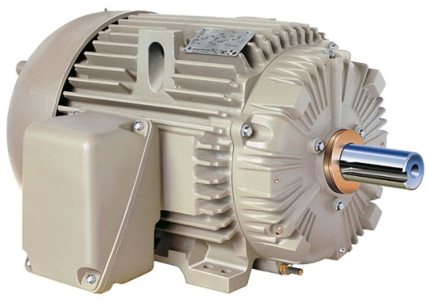
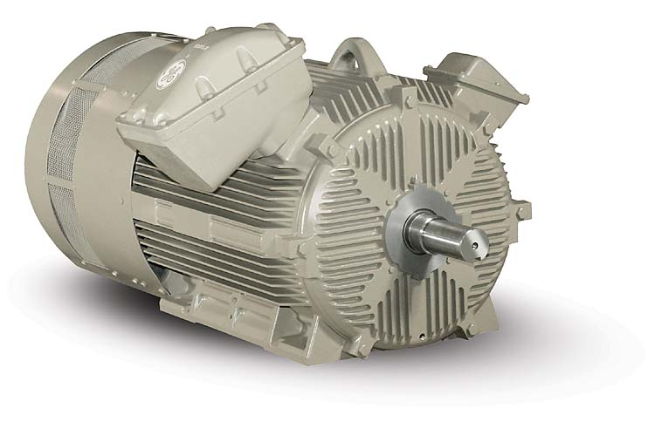

Table of Contents
1. General Requirements............................................................................................3
2. Electrical Requirements......................................................................................…4
3 Mechanical Requirements......................................................................................6
4. Data..............................................................................................………................10
5. Warranty.................................................................................................……..…..10

- GENERAL REQUIREMENTS

  - Purpose
The purpose of this specification is to help motor users specify world class motors for use in applications where IEEE 841 is either directly specified or the application requires IEEE 841 features.

  - Scope
This specification covers continuous duty, horizontal, three phase, integral horsepower, totally enclosed, squirrel cage induction motors in NEMA frame sizes 143-5013 and IEC frame sizes 90-315 which are designed to the IEEE 841 specification.

  - Service Conditions
Unless otherwise specified, motors conforming to this specification shall be suitable for operation in accordance with their rating under the following conditions:
- Ambient temperature -25°C to +40°C.
- Service Factor 1.15.
- Maximum altitude of 1000 meters (3300 feet) above sea level at 40°C ambient
- Indoor or outdoor installations, Severe Duty Applications such as high humidity, chemical laden (corrosive) or salty, non-ocean front, atmospheres.
- Full voltage across the line starting.
- Suitable for use in a Class I Division 2 environment with a T3 temperature code when operated on sine-wave power.

  - Standards
NEMA motors shall meet the IEEE 841 standard. IEC motors shall comply with IEC 60034 and shall include applicable features of the IEEE 841 standard. Exceptions to the IEEE 841 standard shall be noted on the motor’s nameplate.

2. ELECTRICAL REQUIREMENTS

2.1 Operating Characteristics

The motors shall be single voltage 3 lead motors to comply with the IEEE 841 standard. With nameplate voltage and frequency applied, the motor performance shall be as follows:

- Torque: The breakdown torque shall meet the IEEE 841 requirement.
- Current: The motor shall meet the IEEE 841 requirement for locked rotor current. Motor shall also be capable of 20 second stall at six times full load current without injury to the motor components.
- Efficiency: NEMA motors shall have full load nominal efficiency that meets or exceeds those listed for IEEE 841. In addition, the motor efficiency of any individual unit shall be guaranteed to be within 1 NEMA band of the nominal efficiency. Motor efficiency shall be tested per IEEE 112, test method B, using accuracy improvements by segregated loss determination
- Temperature Rise: The temperature rise shall be 80°C or less at 1.0 service factor in compliance with the IEEE 841 standard.
- End Shield temperature rise: The end shield temperature rise shall meet the IEEE 841 requirements.
2.2 Stator and Rotor laminations
The lamination steel used shall be low loss silicon steel with a C5 coating. The stator and rotor slot designs shall be optimized.

2. ELECTRICAL REQUIREMENTS (continued).

2.3 Insulation System
- All 140-449 frame NEMA motors and 90-280 frame IEC motors shall use a UL listed Class H system. Motors shall use a trickle treat process to ensure no voids exist in the winding which virtually eliminates corona. (This process is vastly superior to a dip-and-bake process which traps air in pockets in the winding and does not penetrate into the stator slots.) 500 frame NEMA and 315 frame IEC motors may use a Class F VPI system.
- Form wound motors shall have a sealed insulation system.
- The insulation system shall exceed NEMA MG 1 Part 31 requirements.
- The insulation system shall be compatible with mineral oil and synthetic oil based lubricates per IEEE 841.
- Leads shall be suitable for oil mist lubrication applications.
- The insulation system shall be designed to meet a minimum resistance of 1.5 megohms after exposure in a humidity chamber at 10% humidity for 168hrs in a 40° C ambient.
- All motors shall be tested for partial discharge inception voltage to ensure the motors exceed NEMA MG1 Part 31.
2.4 Frame grounding
All motors shall have a frame ground in compliance with the IEEE 841 standard.
2.5 Space Heaters
If space heaters are used, they shall be thermostatically controlled to ensure the space heater temperature does not exceed the requirements for the Division 2 requirements of IEEE 841.

3. MECHANICAL REQUIREMENTS
  - Stator Frames

- The horsepower to frame assignments for NEMA Motors shall conform to the latest revision of NEMA MG 1 standard for horizontal T frame motors.
- 140-449 frame motors shall be designed with stator cores centered in the stator frame allowing for easy conversion from standard F1 to F2 conduit box location.
- All stator frames shall be supplied with convenient dual mounting holes to allow motors from the same frame diameter to be mounted in the same location without costly changes to the base. (Example: 213-215 frames and 404-405 frames would have mounting holes for each frame. This configuration allows for reduced inventory of standby critical spares.)
- Frames shall be constructed of high strength Class 25 grey iron or better.
- All frames shall include cast-in lifting lugs. (Lifting lugs provide consistent and reliable lifting provisions. Eyebolts can be dangerous if not used properly. Cast-in lifting lugs add another dimension of safety. Lifting lugs also provide means of lifting the motors vertically on 140-449 frame NEMA motors and 90-280 frame IEC motors.)
3.2 Enclosure
Motors shall meet an IP code of IP56 or better.

3. MECHANICAL REQUIREMENTS (continued)

3.3 Bearing System
- All motors shall meet the requirements of IEEE 841 of 26,280 hours of L10 life for belted applications and 50,000 hours of L10 life for direct connected loads. 140-449 frame motors shall also meet 130,000 hours of L10 life for direct connected loads.
- All motors shall have a re-greasable bearing system.
- All machined surfaces of the bearing caps and end shield shall be close running fits.
- Internal bearing caps shall be machined and shall have a gasket between the bearing cap and the end shield.
- Grease entrance and exit cavities shall be pre-charged with Mobil Polyrex- EM™ premium grease to eliminate potential for condensation entering the grease cavity.
- End shields shall be provided with grease fittings and relief plug extended to the outer periphery of the end shield to allow for re-greasing in service.
- Motors shall be field modifiable to oil mist lubrication.
- The bearing system shall be locked to reduce endplay.
3.4 Vibration
Vibration at rated voltage and frequency on 140-449 frame NEMA motors and 90-280 frame IEC motors shall not exceed the limits of 0.04 inches per second (ips) overall vibration as evaluated by NEMA MG1 on ball bearing motors. 500 frame NEMA motors and 315 frame IEC motors shall meet 0.1 inches per second (ips) overall vibration on ball bearing motors.
3.5 Shaft
The shaft shall be constructed of 1045 carbon steel or better and shall be machined to meet NEMA or IEC specifications. The shafts shall also meet all requirements of IEEE 841 including run-out.

3. MECHANICAL REQUIREMENTS (continued)

3.6 Endshields
- End shields shall be high strength class 25 grey iron or better.

- End shields shall be provided with cast-in vibration pads to allow a consistent measuring point for repeatable monitoring with hand held vibration probes.

- The end shields shall include an INPRO Seal on both ends of the motor.

- Condensation drains shall be provided in the lowest point of each motor end shield.
3.7 External Cooling Fan
All fans on TEFC motors shall be corrosion resistant, non-sparking material such as 30% glass filled polypropylene.
3.8 Conduit Box
- The conduit box shall be cast iron or fabricated steel.
- The box shall have a gasket between the conduit box and the motor frame which provides lead separation.
- A gasket shall also be provided between the machined surfaces of the conduit box and cover to provide a waterproof conduit box.
- Bolts securing the conduit box cover shall be on the outside of the box cavity.
- The conduit box shall meet or exceed the volumes as included in IEEE 841 with a threaded conduit hole.
- Grounding provision shall be provided in the conduit box.
- The conduit box shall be able to be rotated in 90-degree increments.
- The internal temperature of the terminal box shall allow use of 75C rated supply conductors for motors rated 600V and below and shall allow the use of 90C rated supply conductors for motors rated above 600V.

3. MECHANICAL REQUIREMENTS (continued)
  - Nameplate
- The nameplate shall be 316 stainless steel.
- The bearing designation shall follow IEEE 841 and shall include the AFBMA designation as opposed to the ABMA designation to comply with IEEE 841.
- The nameplate shall also include the following information:
Motor Type | Enclosure | Motor Weight
Frame Size | Ambient –Max | Cat # (if applicable)
Voltage | Insulation Class | Bearing DE
Full Load Amps | KVA Code | Bearing ODE
Horsepower (or KW) | NEMA Design | Power Factor
Full Load RPM | NEMA Nom. Eff | Max KVAR
Phases | Minimum Guar. Eff. | IP Rating
Frequency | Service Factor | Bearing Lubrication
Time Rating | Min Temp of Sup. Wires | Vibration Limit

3.10 External Hardware
All screws and bolts shall be plated for added corrosion resistance. All bolts shall be flanged hex head and minimum of grade 5.

4. DATA

4.1 Test
Tests shall be performed on each design to assure compliance with NEMA MG 1 and IEEE Std 112 Method B. Each motor shall have a commercial test with results supplied in the motor conduit box. All motors shall be tested for partial discharge inception voltage to ensure the motors exceed NEMA MG1 Part 31.

Data packs shall include outline drawing, connection diagram, installation manual, performance data, and a speed torque current curve.

5. WARRANTY

5.1 Warranty
All 140-449 frame NEMA and 90-280 frame IEC motor mechanical components shall have a 60 month operational warranty and a 66 month from date of shipment warranty, whichever occurs first. All 500 frame NEMA and 315 frame IEC motor mechanical components shall have a 36 month operational warranty and a 42 month from date of shipment warranty whichever occurs first.

