TQ8000

8 CHANNEL CONTROL UNIT



**FEATURES**

• Easy to install with

Low cost of ownership

• Reliability with minimum maintenance  
and simple calibration.

• Field configurable on all parameters and password protected.

• Monitors a wide range of gases with both 4-20 mA and 3 wire catalytic sensors.

• 24v DC, and volt free  
alarm relays, with 4-20 mA and MODBUS outputs for remote indication and alarm generation.



The standard **TQ8000** is an 8 channel stand-alone control unit, which can be expanded up to 48 channels for larger installations. Capable of monitoring inputs from a wide variety of Gas Detectors and many other 4-20mA output devices, such as temperature and pressure.

The **TQ8000** provides 15 configurable relays which can be utilised as ‘volt free’ or 24V DC, to operate remote devices. Also included are individual 4-20mA outputs for interfacing to programmable logic controllers, PC’s and building management systems. Expansion relay cards can also be fitted to provide individual channel alarm contacts on larger systems.

In addition to the alarm relay contacts the **TQ8000** system can also provide MODBUS outputs for integration into 3rd party remote monitoring systems or remote displays.



**TQ Environmental Limited**

**Flanshaw Way 🞄 Wakefield 🞄 West Yorkshire 🞄 WF2 9LP**

**Tel: +44 (0)1924 380700 Fax: +44 (0)1924 361700**

**Email: sales@tqenv.com Web: www.tqenv.com**



|  |  |  |  |  |
| --- | --- | --- | --- | --- |
| SPECIFICATION | | | | |
| Dimensions | 8 Channel  16 Channel  24 Channel  32 Channel | | Height Width Depth  340 mm x 326 mm x 160 mm  600 mm x 600 mm x 210 mm  600 mm x 600 mm x 210 mm  800 mm x 600 mm x 210 mm |
| Rating | IP54 | | |
| Power Input | Universal; 85 to 254 Volts ac 50/60Hz (24V dc on request) @ 100VA | | |
| Cable Entry | Bottom gland plate as standard | | |
| Calibration | Fixed password protected Adjustable Zero, Span, AL1 & AL2 | | |
| Display and indications | 4 x 40 character alphanumeric, back lit LCD Power on, Gas Alarm 1 & 2, Fault Alarm and Inhibit | | |
| Alarms | Alarm 1 and Alarm 2; Adjustable between 0% & 100% of FSD. | | |
| Relays | Output via configurable relays RL2 to RL16. RL1 dedicated Fault. SPCO rated, 24 vdc/280V ac @ 12A resistive | | |
| Inhibit | Evoked on individual channel outputs when in calibration and channel selectable. Operates ‘Inhibit LED’ and ‘Fault’ relay | | |
| Front Panel Control | ‘Reset’, ‘Hold’, & ‘Mute’ | | |
| Internal Panel Control | | Channel advance and Menu operation. | |
| Additional outputs | | MODBUS enabled for remote monitoring via full control mimic panel or 3rd party monitoring. | |
| Internal Audible | | Gas/Fault 80dB | |

The TQ8000 is housed in an IP54 rated metal, wall mounted enclosure, with entry for field cabling through the bottom gland plate.

The alarm and fault status of each channel is displayed on the front panel.

Each channel has 2 user defined alarm thresholds, which operate the front panel LED’s and the internal sounder.

Operator interface controls are available internally for the adjustment of alarm set points, channel inhibit, relays, and calibration span and zero. These controls are customer configurable and password protected.

All units are supplied with a comprehensive manual detailing installation, maintenance and easy to follow operating instructions.

Can be provided with separate or inbuilt battery back up.

TQ Environmental Limited, operate a policy of continual product development which means the specification is subject to change without prior notice. For full assistance with your application contact TQ Environmental.

***Gas Monitoring Solutions***



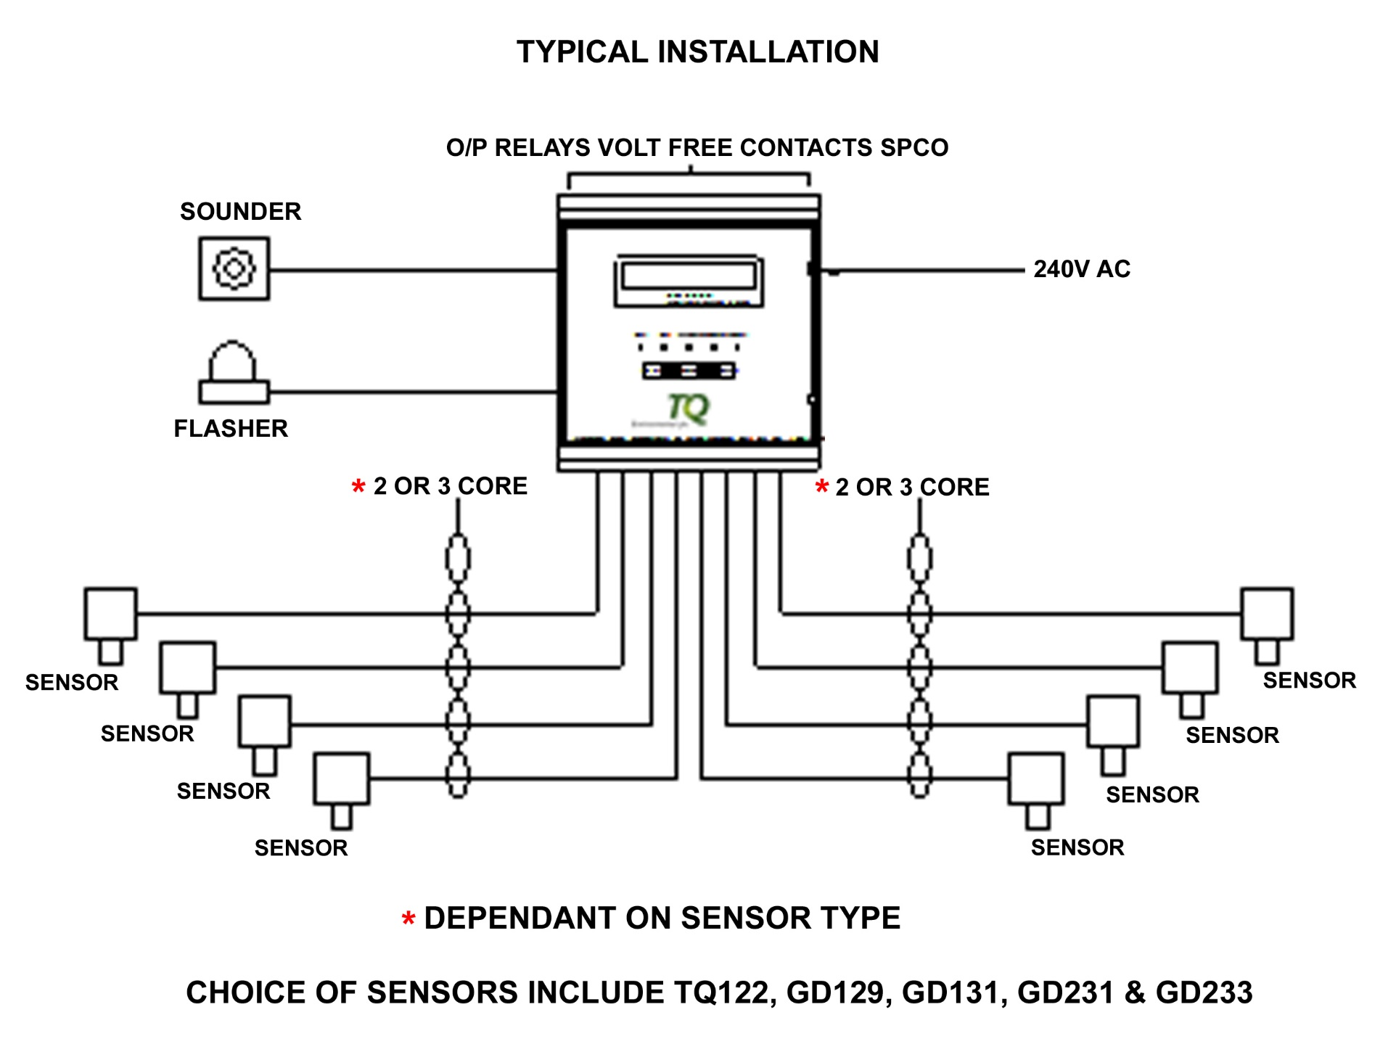

|  |  |  |
| --- | --- | --- |
| **PART LIST** |  | |
| 8 Channel, with 16 relay alarm card | | 370-600-08 |
| 16 Channel, with 16 relay alarm card | | 370-600-16 |
| 24 Channel, with 16 relay alarm card | | 370-600-24 |
| 32 Channel, with 16 relay alarm card | | 370-600-32 |
| Please consult TQ Environmental for other options including, battery backup, additional relays, printers and remote display panels. | |  |

D3-8000-0315

Cert No. LRQ 0958602

**TQ Environmental Limited**

**Flanshaw Way 🞄 Wakefield 🞄 West Yorkshire 🞄 WF2 9LP**

**Tel: +44 (0)1924 380700 Fax: +44 (0)1924 361700**

**Email: sales@tqenv.com Web: www.tqenv.com**



Xn-ppp-mmyy

**Cert No. LRQ 0958602**